Working in the Cloud

with ClearMedia Academy

Enabling MFA on F-Secure PSB Portal

* Surf to the F-Secure PSB portal:



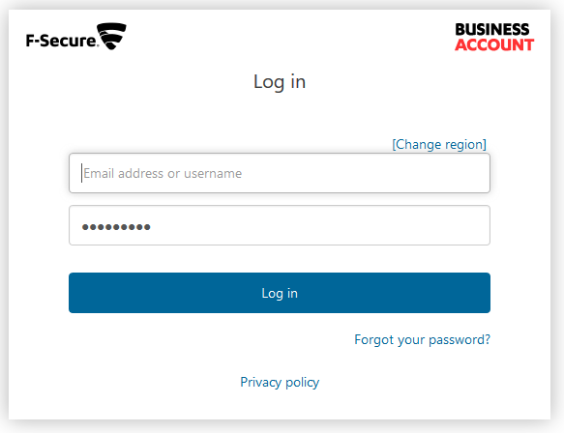

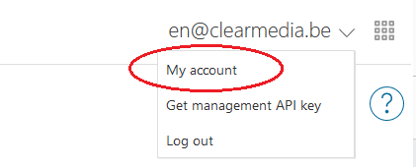

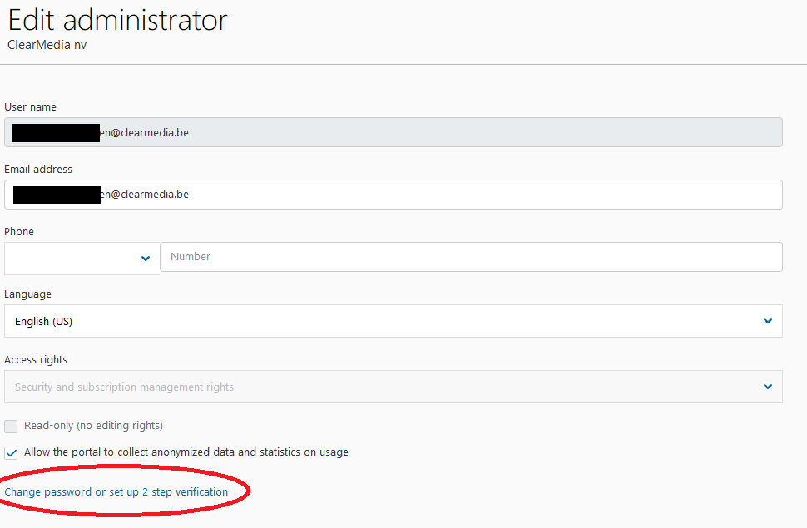

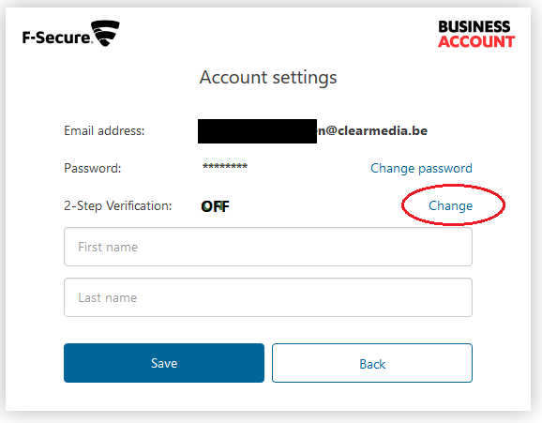

If successful, you should get the bellow message the next time you logon.

